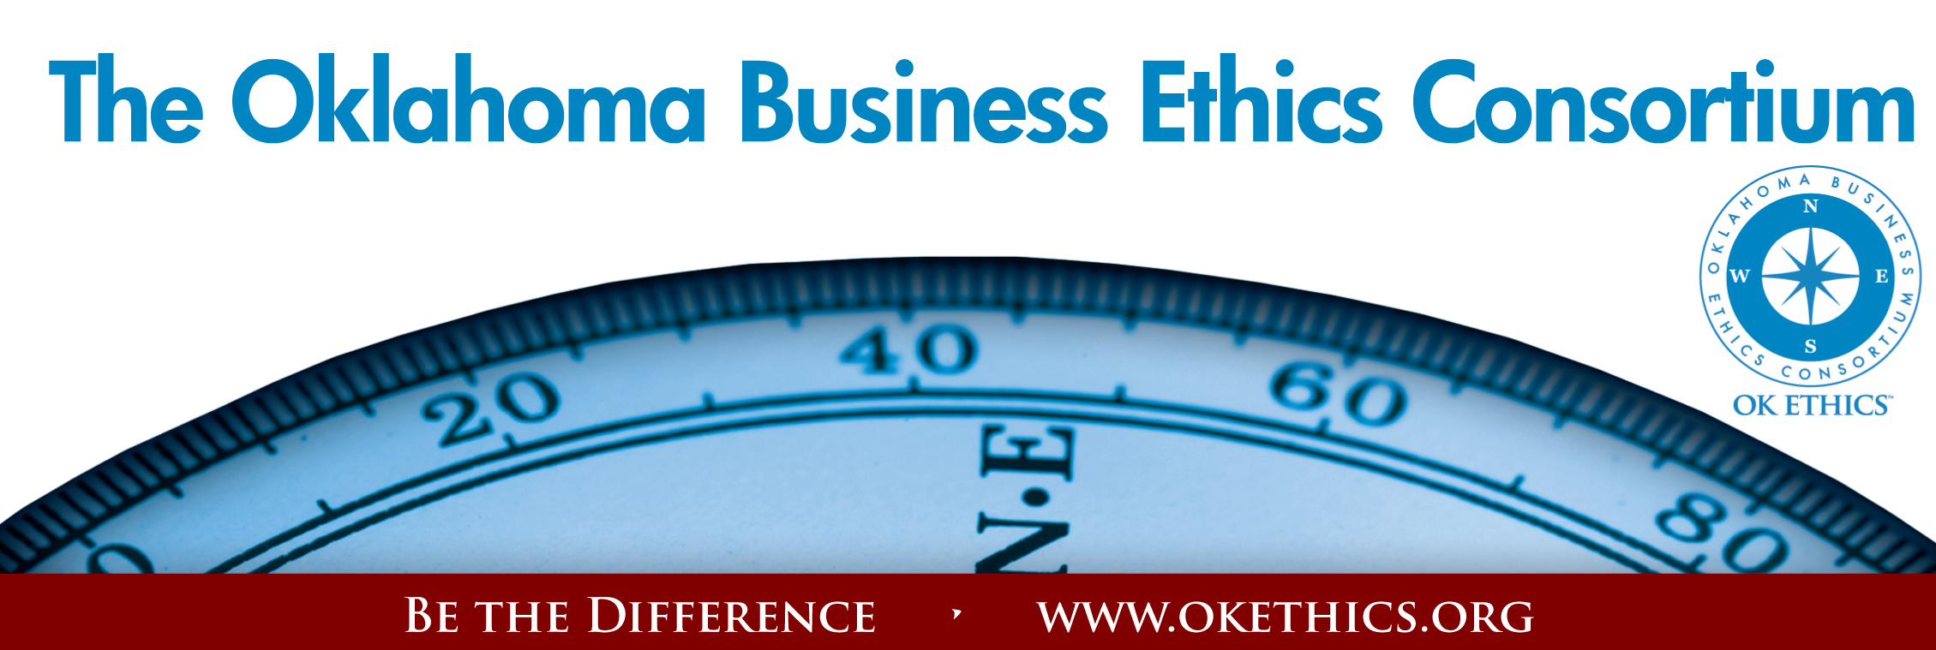
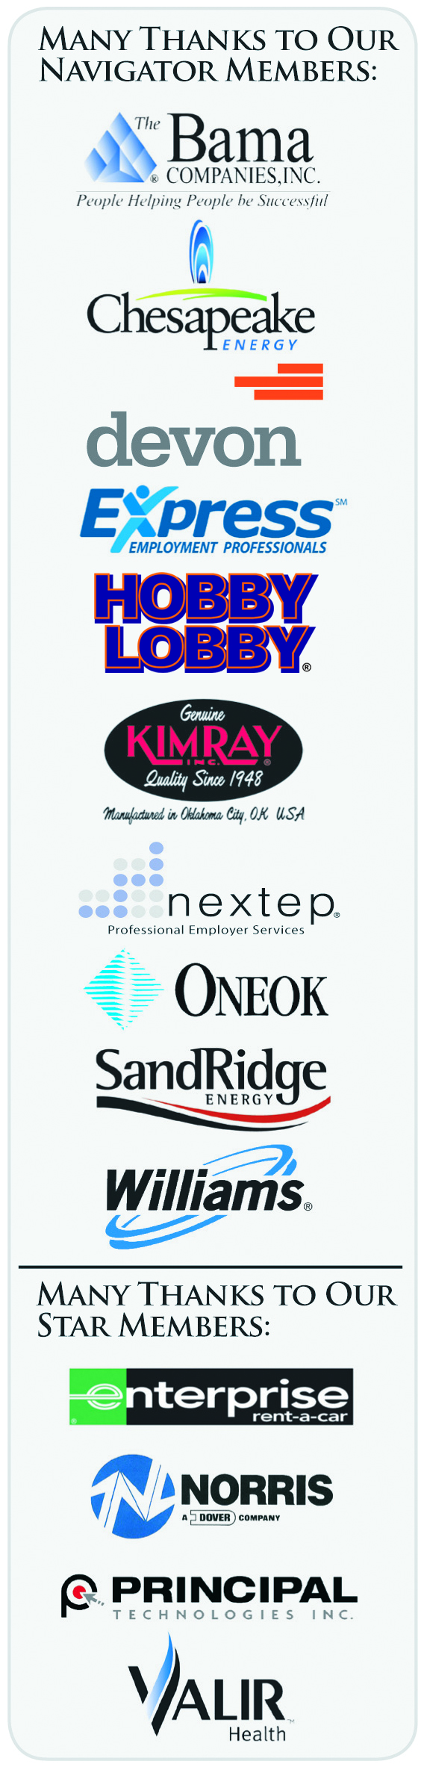
Oklahoma Business Ethics Consortium – May 20, 2009
- Welcome & Kudos
“Never doubt that a small group of committed people can change the world. Indeed, it is the only thing that always has.” – Margaret Mead

Special Guests:
- David Costello, CEO and President of NASBA & NASBA CPT
- Lisa Axisa, Executive Director of NASBA CPT
- Alfonzo Alexander, Chief Relationship Officer, NASBA
& VP of NASBA CPT
- Larry Bridgesmith, CPT Board Member
- Ryan Hirsch, CPT Staff Member/Communications Specialist (Video)
- Jenn Bouchard, CPT Activities Coordinator

* NASBA = National Association of State Boards of Accountancy
* CPT = Center for Public Trust

Oklahoma Accountancy Board:
Special thanks to Edith Steele, Executive Director
for nominating OK Ethics for NASBA’S CPT AWARD!

Board:
Carlos Johnson,
CPA, Vice Chairman
Barbara Ley, CPA, Secretary
Wade Biswell, CPA
Staff:
Edith Steele, Executive Director
Nicole Prieto Johns, Deputy Director
Colin Autin, Peer Review
Coordinator

Volunteers:
Mark Neumeister, D.R. Payne & Associates, Inc. – Registration Leader
Mary Kay Huggard, Principal Technologies – Registration Vice Chair
Team Members : Ashley Warne, Kara Stevi and Josie Strickland

Terre Bettis, Coppermark Bank – Chief Ambassador
Thanks to her team of enthusiastic ambassadors for helping us with greeting our guests today:

- Shannon Hiebert,
Enterprise Rent-A-Car
- Chade Nash,
Gabbard & Co.
- Debbie Gardner,
Accel Financial

- Sherree Murray, SNU
- Linda Streun, Ideal
Homes
- Kimberly Nation,
Accounting Principals

Lisa Giles, Eide Bailly, LLP – Chief Identification Officer (name badges)
Linda Manaugh, Metro Technology Centers – Agendas
Connie Barwick, Maximum Multi Media Creations –PowerPoint
Valerie Fried, Capitol Abstract & Title Company – Visitor welcome pkgs.
II. Introduction of Special Guest Garyl Geist, President - OK Ethics Consortium Board of Directors
Chief Executive Officer - Valir Health
THE CENTER FOR PUBLIC TRUST – “BEING A DIFFERENCE” AWARD
DAVID COSETLLO, CEO & PRESIDENT OF NASBA

III. Introduction of Keynote Speaker Bob Byrne – OK Ethics Foundation Board of Directors
Ethics Advisor – Boeing

LARRY BRIDGESMTIH, EXECUTIVE DIRECTOR,
INSTITUTE FOR CONFLICT RESOLUTION,
LIPSCOMB UNIVERSITY
NASBA BOARD OF DIRECTORS
“Ethics & Interpersonal Conflict”

General Disclaimer: Members of the Oklahoma Business Ethics Consortium frequently share information concerning various issues and developments that may have legal implications. The discussions, commentary, and handouts at Consortium meetings or presentations to other organizations are for general informational purposes only. They cover only some aspects of the subject topic, and do not constitute a complete legal analysis of the topic or how it might apply to any particular set of facts. Before taking any action based on information presented during a Consortium event, participants are encouraged to consult a qualified attorney.

The observations and comments of presenters at Consortium meetings and networking are the views and opinions of the presenter and do not constitute the opinion or policies of the Consortium or any of its members. Presenters are respectfully requested to avoid profanity, preaching, politics and self-promotion during their lectures.
CPE CERTIFICATES
It is the responsibility of participants to demonstrate applicability of each program for demonstration of earned CPE credits, to his/her area of practice. OK Ethics makes no guarantees. Also, attendees must be present to accept CPE certificate at the conclusion of the program.

CPE CERTIFICATES WILL BE ISSUED AT THE BACK OF THE ROOM ON
BEHALF OF NASBA AT THE CONCLUSION OF THIS EVENT
NOTE THAT WE WILL NOT EMAIL THESE

YOU MUST BE REGISTERED ON OUR ATTENDANCE LIST TO RECEIVE A CERTIFICATE – NASBA WILL COLLECT YOUR NAME TAG FOR THEIR RECORDS

Please note that NASBA rules require disqualification of participants from receiving certificates if they exit for any time during Mr. Bridgesmith’s presentation.
If you have questions about the certificates, please contact
Jenn Bouchard, Activities Coordinator, NASBA Center for the Public Trust
Direct: (615) 564.2129; jbouchard@nasba.org

IV. Upcoming Events: (Note that OKC Chapter will take a summer break in June/July)

MOORE-NORMAN CHAPTER PRESENTS:
June 17 | August 25
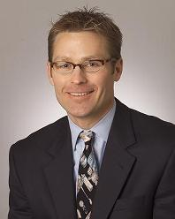  Vernon McKown  Ideal Homes  of Norman | 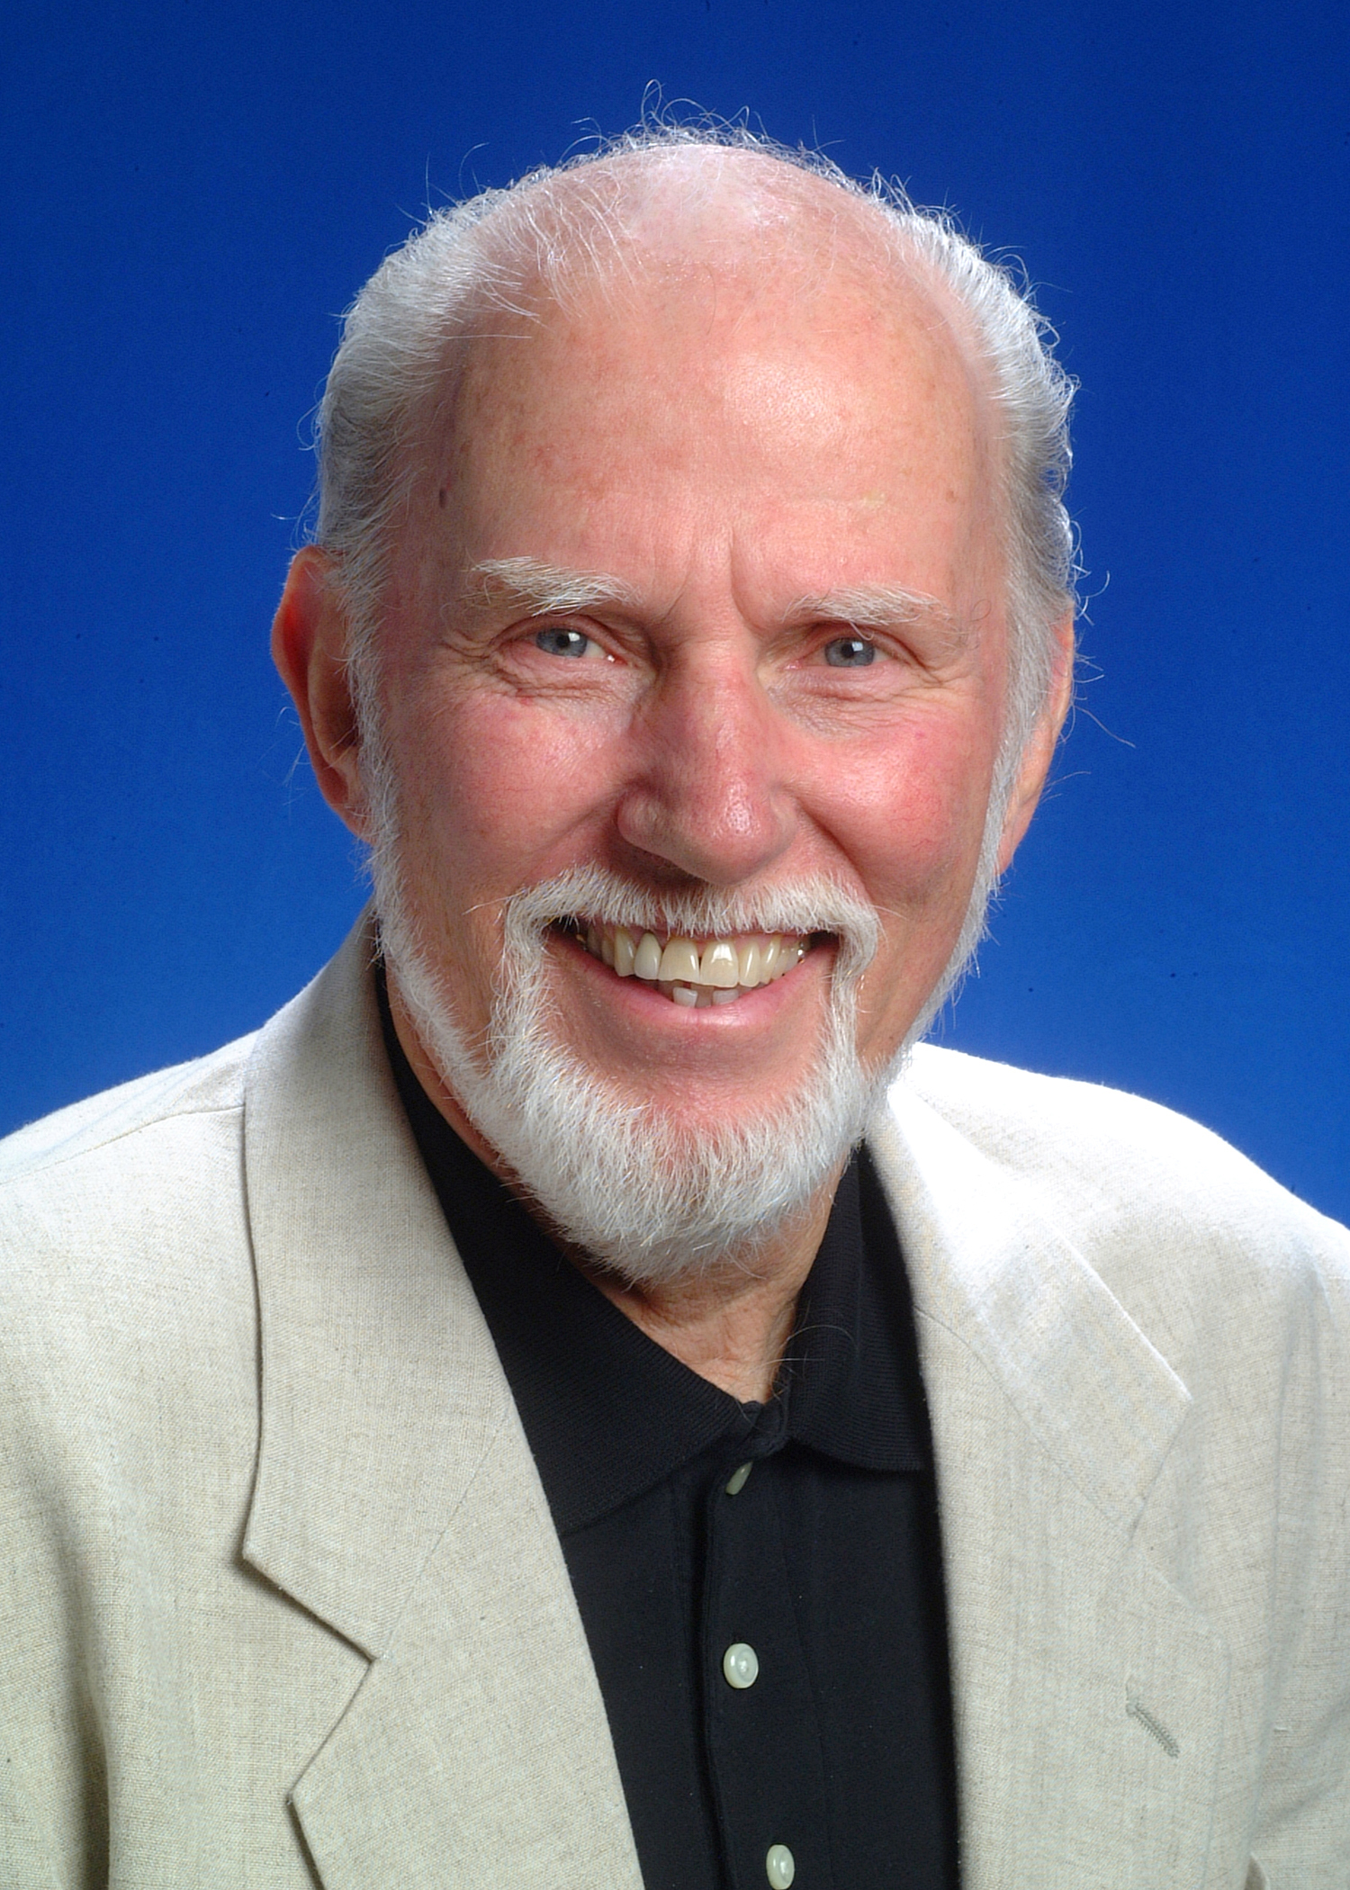  Dr. Tom Boyd  University of Oklahoma
 | “Ethical Maturity”  As individuals, we are constantly striving to evolve. While there are programs delving into emotional intelligence, this program will provide insights on developing  ethical maturity:  Doing the right thing for the right reasons.  Tom W. Boyd is the David Ross Boyd Professor Emeritus of Philosophy at the University of Oklahoma. After teaching philosophy of religion and ethics there for 28 years, he retired from fulltime teaching in 1997. He also retired from the ordained ministry in the Presbyterian Church USA in the summer of 1998.  Tom holds four earned degrees, including a Ph.D. in Religion from Vanderbilt University in 1973. His academic specialization is in philosophical theology, theories of religion, religion and culture, and ethics. His current concentration is on the relation among world religions and the relation between religion and culture. He also studies the impact  of religion on ethics.
  Vernon McKown is Co-owner and President of Sales of Ideal Homes of Norman, founded in 1990. Vernon is a frequent presenter at the National Builder's Show and EEBA Conference. He has served on a wide variety of philanthropic and charitable boards. He has a Bachelors Degree in Business Administration from the University of Oklahoma.
  In its' 19th year of business, Ideal Homes built more than 500 new homes per year and $75 million in sales. They are the first Builder in America to get Energy Star for homes under $150,000, and they are also the first Builder in the state of Oklahoma to introduce guaranteed utilities. They have been recognized as one of the 101 Best Residential Construction Companies to work for in the United States. In 2007, Ideal was named America’s Best Builder.
OKC CHAPTER PRESENTS: (Note that OKC will be taking summer break in June/July)
September 9  “The Speed of Trust”  Based on Stephen Covey’s latest book  Presented by  William J. Siems, Boeing  Certified Covey Trainer  Recommended for 1 CPE in Ethics | 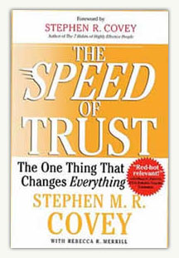

TULSA EVENTS
May 28 | “The Ethics of Layoffs”

September 24 | “How to Develop Productive & Loyal Employees”
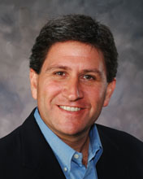 | Presented by Chet Cadieux  Chief Executive Officer  QuikTrip

REGISTER FOR ALL EVENTS AT
WWW.OKETHICS.ORG

V. Other upcoming programs of interest:

Character First Institute:
OK Ethics is honored by our friendship with the
Character First! Institute.
They provided wisdom and the basis for our Guiding Principles.
For more information on upcoming Business and Community Leaders' Luncheon, please contact them at 815-0001, or visit www.characterok.org./
Cost is $10 per person. The next topic is
“Justice in the Workplace” to be presented on
Tuesday, May 26 or Thursday, May 28.
Justice vs. Corruption
Taking personal responsibility to uphold what is pure, right, and true.
Justice gives a moral compass and motivates you to do the right thing. Justice motivates individuals to correct mistakes and inconsistencies and does not let others' influence sway them from doing what is right. When you have done wrong, apologize, make restitution, or correct the situation in order to do what is right in situations and in relationships.
"Justice consists not in being neutral between right and wrong, but in finding out the right and upholding it, wherever found, against the wrong." —Theodore Roosevelt

